2011
Дегтярева Елена Александровна 624380 Свердловская область, город Верхотурье, улица Конечная, дом 7 ГБОУ СО Верхотурская гимназия учитель английского языка 89089070049
01.01.2011
Degtyareva E. A. History of Verkhoturye.
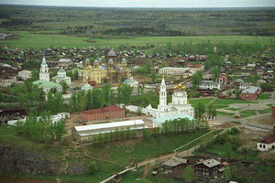
Элективный курс “History of Verkhoturye” .
Пояснительная записка.
Предлагаемый элективный курс предназначен для учащихся 9-11-х классов общеобразовательных учреждений, способствует обеспечению повышенного уровня владения английским языком, носит метапредметный характер и направлен на интеграцию филологических и краеведческих знаний учащихся.
Кроме того, курс способствует развитию интеллектуальных, творческих, коммуникативных умений: а) работать с информацией;
б) генерировать идеи;
в) лаконично излагать свою мысль.
Цели и задачи элективного курса:
• Развитие и образование учащихся средствами иностранного языка через осознание ими роли родной культуры и привитие уважения и любви к родной культуре.
• Формирование понимания важности изучения иностранного языка как средства достижения взаимопонимания между людьми.
• Формирование социокультурной компетенции учащихся.
Курс строится в русле задач развития и воспитания коммуникативной культуры школьников, расширения и обогащения их коммуникативного и жизненного опыта в новом контексте общения, расширение кругозора учащихся по теме «Родной край».
Обучение на основе данного курса носит ознакомительный характер, сочетая различные формы работы (групповую, индивидуальную, парную), создавая коммуникативную атмосферу в классе, стимулируя общение на предложенную учащимся тему.
Послетекстовые задания направлены
а) на проверку понимания основного содержания прочитанного, выделение основных фактов, определение темы и идеи текста;
б) на проверку понимания деталей, усвоение новой лексики;
в) творческие задания, побуждающие учащихся к устному и письменному высказыванию.

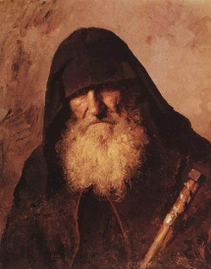
Good day, my dear children! I am Monk of Saint-Nikola’s monastery in Verkhoturye.
It is a very beautiful and old town. I want to tell you about it: its history, its churches, its past. At first tell me please what do you know about this town?
These words help you to translate the text:
the Urals | Уральские горы
Verkhoturye | Верхотурье
Fortress | крепость
the river Tura | река Тура
verst | верста
the streltsy | стрельцы
kremlin | кремль
ostrog (stockade) | острог
posad | посад
the voivodes | воеводы
temple | храм
the Trinity Cathedral | Троицкий собор
The Nikolaevsky Monastery | Николаевский монастырь
The Krestovozdvizhensky Cathedral | Крестовоздвиженский собор
The Pokrovsky Monastery  The Protection Nunnery | Покровский монастырь
Gospel | Евангелие
Orthodox | православный
a nobleman | святой
Mostovaya | Мостовая

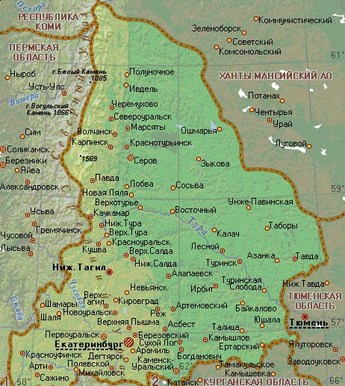
I begin my story.
Among the Urals historical settlements the town Verkhoturye is distinct, surrounded by a special halo. A small town became the «gates to Siberia - a gigantic country added to the State of Moscow.
Artemy Babinov became a pioneer and builder of a new road. The Babinov Road connected Solikamsk with the upper reaches of the river Tura. As a result, the distance between Moscow and Siberia was cut down by 1000 versts.
The construction of Verkhoturye began in spring 1598 by the Tsar’s edict. The fortress was erected by people hired from Cherdyn, the streltsy from a small town Lozva and war prisoners taken under the fall of the Kazan Khanate. Already in August 1598 a messenger arrived in Moscow with a «draught» for the Verkhoturye wooden kremlin and ostrog (stockade). The first fortress or wooden Kremlin was felled on the sheer stone bank of the Tura-river. Here the money, sable and salt treasury, munitions and grain supplies for Siberian towns were kept. The military garrisons were also quartered in this place. In the 1600s the youngest sons of the Russian nobility, clergy, townspeople, peasants and streltsy formed a settlement next to the kremlia, The new settlement - «posad» -gradually filled the interfluvial area of the Tura-river and its two tributaries. The fortifications of the kremlin and the posad converged. In the second half of the 17th century they extended for 640-645 sagenes. The wooden 10-13 sagenes in high towers of ostrog, were linked with wooden walls too, thus making Verkhoturye an impregnable place.
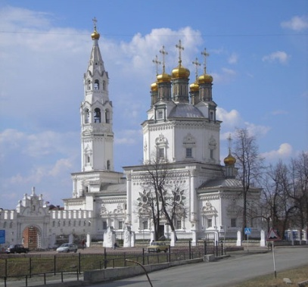
Verhoture Kremlin
As well as for many other cities, which were the first advanced posts of development of Urals Mountains and Siberia, the wooden fortress served as the beginning of Verhoturye. It was erected on ennobled rocky bank of the river Tura in 1598. On the territory of the fortress there were barns for treasury, House of Commander, court yard, wooden Trinity church, and other administrative and economic constructions.
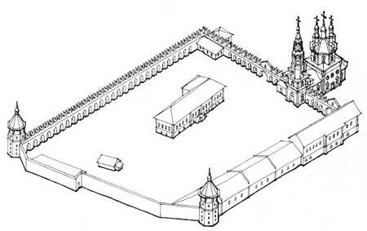
Up to the end of XVII century the wooden fortress repeatedly suffered from fires and was reconstructed. In 1698 in, as well as in Tobolsk, under Peter I decree the construction of the stone Kremlin began. The territory of the Kremlin was enclosed by fortifications and towers. Inside of the new stone House of Commander, Decrees chambers, barns, guards’ room and cooks’ room were erected. The brightest architectural dominant of Verhoture Kremlin became stone Trinity cathedral constructed on blessing of the Siberian metropolitan Filofey Leschinsky.
Today on the territory of Verhoture Kremlin there are several administrative buildings, which are the monuments of architecture of XVIII - XIX centuries. Among them: the House of Commander, Decrees chambers, barns, district exchequer.

On the Siberian tsar's road, settlements grew and expanded under close attention from the central Moscow state. According to the tsaris edict, 50 coachmen from coastal towns moved to Verkhoturye in 1600. So, the coachmen township, Yamskaya, was formed.
In the middle of the 17th century on the right bank of the Tura-river, opposite the fortress, the Zarechny township was founded, whose settlers were mainly peasants as well as retired streltsy and gunners.
The frontier position of the town, through which goods went both from Russia to Siberia and China and vice versa, required the establishment of a customs court in Verkhoturye. All the traders and passers-by came in person to customs, showed their documents, paid duties and got trading licenses. By tsar's edict the Customs House of Verkhoturye was granted the exclusive right to subject the property and goods of the Siberian voivodes⁵ to customs examination and even confiscate them to the treasure.
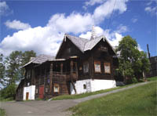
Gostiny Dvor, already established by 1600, was used as a storehouse for merchant goods; the wholesale trade was carried out here too. In 1б07, alongside Tobolsk and Beryosovy, Verkhoturye was granted the first town seal. This confirmed the important place of Verkhoturye in the customs system of the Moscow state. A sable under a tree was depicted on the seal. Later, letter «B» was added here, referring to the name of the town.
The symbol of the sable revealed the main purpose of Russian expansion in Siberia - furs enriched the state treasury.
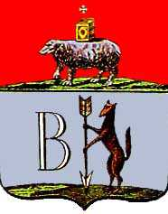
The administrative influence of Verkhoturye spread and, as a result, in 1687 an arrow was added to the seal. The arrow reflected the special strategic position of Verkhoturye which lay on the border of European Russia and Siberia.
In 1783 the Tsar approved the coat-of-arms of the district town Verkhoturye, of Perm vicegerency (Perm province afterwards). At the top of the heraldic shield there was a governor's coat-of-arms which represented a silver bear in the red field, with a Gospel in a gold setting placed over it. A silver cross above it meant «firstly -wild manners of the inhabitants, secondly - enlightment through the adoption of Christian law». The sable with the arrow and letter «B» were placed in the silver field at the bottom.
Though nominally the voivodes of Verkhoturye were under those of Tobolsk, the special town position on the border between the central Russia and Siberia led to their taking direct orders from Moscow. The Russian nobility and those from high-born families were appointed the voivodes in Verkhoturye. Sometimes among them were those, related to the Bar"s family, such as Miloslavsky Lopukhin, Naryshkin.
The Moscow government in every way possible encouraged local initiative to organise Orthodox monasteries and temples. In 1604 a religious monk Iova the Gothamite received permission to found St. Nickolas Monastery in Verkhoturye - the first Christian cloister in Zauralye.
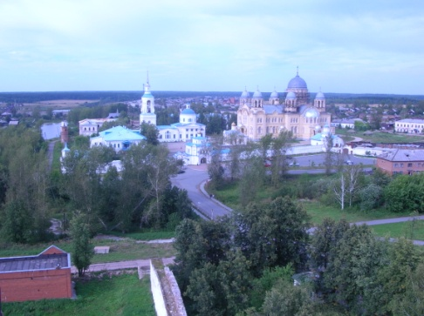
The history of Saint Nikolaev monastery
The monastery was founded in 1604. Monk Ion was the founder of the monastery. In 1604 he asked permission at Tsar Boris Godunov for construction of a temple after the name of Saint Nikolay Wonder Maker with parts of it after the names of Saint Boris and Gleb.
A crucial event in the life of the monastery was when the monastery got the relics of Saint Simeon Wonder Maker. On September, 12th, 1704 they were carried to monastic wooden church after the name of the Cover of Saint Virgin. So every year on September, 12th in the monastery celebratory divine service is made. From the beginning of 18 century Verhoture monks conducted records about Simeon’s miracles, collected certificates of eyewitnesses. On the basis of these records, Siberian annals and materials of checks in the monastery the data file "Life of Saint Simeon Wonder Maker" was made.
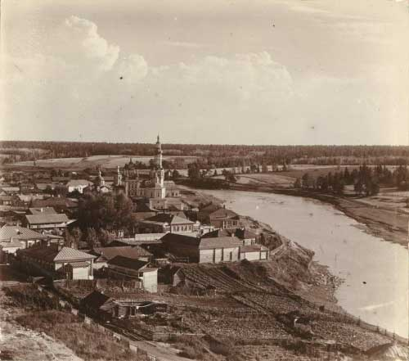
After rough events of 1917 - 1920 the new authority began struggle against church. Monasteries were declared to be strongholds of reaction and alien ideology, their closing, plunder of relics, arrests of clergy began. Within the Soviet authority in a monastery the colony for minor criminals was placed. In 1990 Verhoture Nikolaev monastery was revived to spiritual life.
In 1621 the Protection Nunnery was established in Verkhoturye by the first Siberian archbishop Cyprian.
The first temples in Verkhoturye were badly in need of church-plate and prayer-books. Tsar Boris Godunov sent a set with nine icons, Holy Gates with a Canopy, sacred images, a bell and a Mineia (prayer-book) to the Trinity Cathedral, which was already in existence by 1601.
Tsar Alexei Mikhailovich also granted icons, books and other sacred objects. Precious gifts were given to the monaster of St. Nickolas Church too, such as two Holy Gates with a Canopy, prayer-books, two bells as well as a great number of icons.
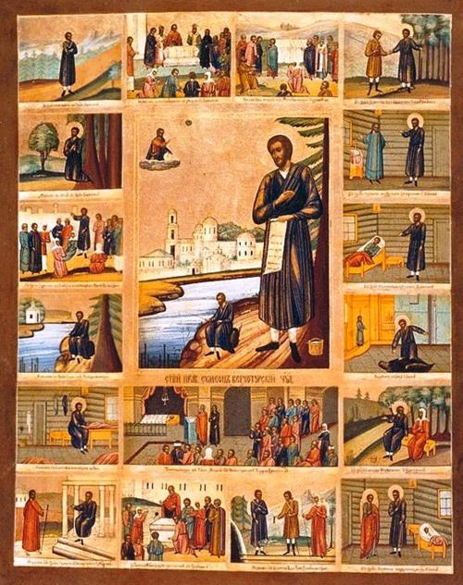
The Orthodox population of the Urals and contiguous regions of Russia has long since revered the name of St. Simeon the Holy, who worked wonders in Verkhoturye. According to the legend, a nobleman Simeon left his native land in European Russia and settled in the village.
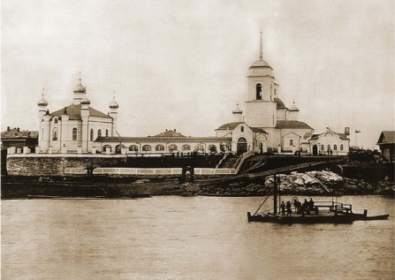
Merkushino in the vicinity of Verkhoturye. He made his living by fishing and sewing fur-coats. Simeon didn't live more than 40 years but his body survived in the ground undeceived for many years. His relics were subjected to examination and in September 12, 1704 moved to St. Nickolas Monastery in Verkhoturye.
The journey from Verkhoturye to the East could be made by land and by the river Tura. The Moscow government placed a shipyard in Verkhoturye to send grain supplies and military equipment to Siberian towns and ostrogs. The big heavy ships for navigation in the Arctic Ocean were built there, as well as small river boats.
As the Tura was not deep enough near the town, the ships from Verkhoturye were half-loaded up to the village Merkushino and only set off further after full shipment. Afterwards, a large shipyard was built in Merkushino itself.
The events of the second half the 18th century i.e. abolition of inland customs in Russia and transfer of Siberian High Road much further south of Verkhoturye, showed how greatly prosperity and development depended on its location on the main road to Siberia. The town became disconnected with the trading routes.
The appearance of a great number of mining territories within the confines of the Verkhoturye district of the 17th century with their special subordination, considerably reduced the administrative influence of Verkhoturye.
Life in the town came to a standstill and nothing seemed able to change the fatal turn in Verkhoturye history.
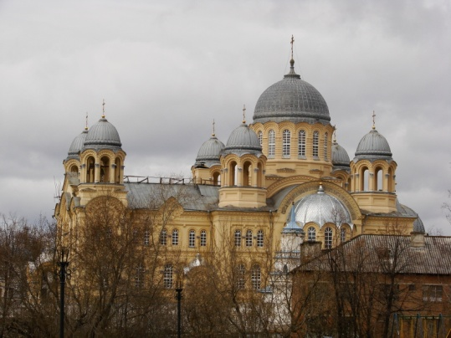
The abolition of serfdom in Russia marked a new epoch. The first changes in Verkhoturye dealt with the elimination of the special Mining Management Board in the Urals and the introduction of local self-government (1860-1870). With the efforts of the latter, a hospital community, schools, a meteorological station, a veterinary surgery and a district treasury were built.
Cross Cathedral
Construction of the Cathedral of the Exaltation of the Cross was due to the fact that at the beginning of the twentieth century churches of St. Nicholas monastery could not accommodate the ever-increasing influx of people make pilgrimages to holy relics of Righteous Simeon Verkhoturye. The construction of this temple abbot, Father Aref, and then his father Xenophon, saw the need and because of the increasingly complex situation in the political and spiritual life of Russia, demanding the confidence of the people.
Construction of the Cathedral of the Holy Cross was carried out on the project of architect A. Turchevicha Permian, known by such prominent temples as Nicholas Cathedral Belogorskiy Monastery of St. Nicholas (St. John the Baptist) Church in Kungur, Cathedral in Orenburg, a temple on Motovilihovskom plant in Perm, etc.
Holy Cross Cathedral was founded on Sept. 12, 1905 - the feast of relics of St. Simeon the Righteous Verkhoturye. A lot of effort to put its construction rector of St. Nicholas Monastery - the father of Xenophon. Consecration of the Cathedral and the transfer of his relics Simeon Verkhoturye held September 11, 1913, during the celebration of 300 years of the Romanov dynasty. On this day, the monastery received a telegram from Livadia from the royal family: "Verkhoturye. Nicholas Convent. Pastor Fr. Xenophon. I heartily welcome you and take with vysokotorzhestvennym day of consecration of a new church, our beloved abode and tomorrow's great holiday. We ask your prayers before the shrine of saint. Nicholas. Anastasia ". Krestovozdvizhensky In the cathedral, on a silver shrine with the relics of Simeon the Righteous was erected canopy, donated the monastery of the imperial family. Gilded canopy was under the old gold with a silver inscription:" This canopy was built to the relics of Simeon the Righteous in Verkhotursk Nicholas Monastery expense of love and pious, autocratic, the Great Emperor Nicholas Aleksandorovicha, the devout Empress Alexandra, Tsarevich Alexis, and believing Great Duchesses Olga, Tatiana, Maria, Anastasia Nikolaeva in the year of Our Lord 1914 May 25.
Holy Cross Cathedral has become one of the largest churches in Russia. He was able to simultaneously accommodate about 4000 people. Majestic cathedral seemed to support the value Verkhoturie in Orthodox life in Russia. Imagination contemporaries were struck by the beauty of its decoration. The domes of the cathedral was covered with a smooth zinc sheet overlaid Rustam. Its central iconostasis was made of faience factory in the Moscow MS Kuznetsova.
ancient — древний
to found — основать
fortress — крепость
to destroy — разрушать
to restore — восстановить
chapel — часовня
church — церковь
dome — купол
chamber — палата
pillar — столб
cathedral — собор
century — век
erect — построить
state — государство
prison — тюрьма
to exile — ссылать
death — смерть
to capture — захватить
detachment — отряд
highway — тракт

In 1919 Verkhoturye Soviet power was established, and a year later, at the insistence of officials of the provincial authorities in Krestovozdvizhensky council held an autopsy of the relics of St. Simeon the Righteous Verkhoturye. Soon Archimandrite Xenophon was arrested. His earthly life ended in 1933 Belomorbaltlage ... In 30-ies of the Cross Cathedral was finally closed to the faithful. Barbary was defeated him Stoneware iconostasis. Attempts were made to renovations of the temple under the cinema, and later, for the needs of the colony for juvenile offenders, situated on the territory of the monastery.
In 1990, St. Nikolavesky monastery was returned to the Orthodox Church. Today, the hard work of his brother and many other indifferent people who have made a contribution to the revival of the Holy Cross Cathedral, appear before the eyes of the pilgrims who came to worship the relics Verkhoturie.

The monastic territory was extended to 11 hectares and its new Cathedral of the Exaltation of the Cross could house 8000 prayers - nearly all die town population. And if in the late 19th century die number of pilgrims attending St.Nickolas Monastery reached 50,000 a year, during World War I the monastery was visited by 90,000 to 120,000 pilgrims.
Before the Revolution of 1917, the population of Verkhoturye consisted mainly of clergy, petty bourgeoisie, merchants and craftsmen. Strong religious beliefs and firm monarchist outlook conditioned stout resistance to the new power. The Soviets could not accept the religious traditions of the.town, or the fact mat it was a place of pilgrimage. Terror and militant atheism reigned in post-revolutionary Verkhoturye. Monasteries and churches were closed and the relics of St Simeon were taken out to the Nizhny Tagil Museum
After the closing of St. Nickolas Monastery (1926), its territory was given to the penitentiary for juvenile offenders, which, in 1935, passed under the jurisdiction of NKVD and was renamed as a prison camp. By that time the influx of deportees from the European part of the country had increased. In the late 1930s the Chief Board of SevUralLag settled in the forgotten capital of the Urals. The NKVD camps and timber-felling sites were formed in its vicinity which became the basis for further development of local timber-cutting and woodworking -Castries of the Verkhoturye region.
A settlement for prisoners of war, participating in the construction of Verkhoturye hydro-electric power station( 1948), was set up on the river Mostovaya. In the same year, equipment from Germany was assembled in the building of a former state storehouse. Thus originated the Verkhoturye skates plant. The resources of wood and electricity favoured the construction of a wood chemical plant, with its first product being manufactured in 1957.
Verkhoturye of the 1960s still kept the rudiments of GULAG. The largest prison camp of the Ministry of Home Affairs of RSFSR and a famous rehabilitation centre for alcoholics were located here. This period of town history was, in the main, characterized by the preparation for the 50th anniversary of October Revolution. A district committee of CPSU, a palace of culture, a cinema, a bathhouse, a maternity hospital and a reinforced concrete bridge over the Tura-river were built at that time.
1990 was the turning point in the fate of Verkhoturye: a prison camp was withdrawn from the St. Nickolas monastery and the old Urals cloister restored to life. In 1991, the Protection nunnery was reopened.
Relics of Simeon the Holy were brought back to the St. Nickolas monastery and the Simeon church was restored on the burial place of Simeon the Holy.
In the times of the severe economic crisis, a fantastic decision was made to launch a grandiose programme aimed at reviving of the spiritual capital of the Urals. It was the Governor of the Sverdlovsk Oblast who made a plan of specific restoration and construction works out of an idea.President Yeltsin has made the first contribution for the implementation of this plan.
There is also reason to hope that Verkhoturye will be the locality of mass pilgrimage and a tourist centre with its holy places, beautiful architectural ensemble, rich history, and fabulous Urals naaire. What is more, there are people willing to breathe new life into our spiritual, cultural and historical sacred place.

Tasks after reading.
Read and translate the text.
Historical information about Verkhoturye.
Verkhoturye is the oldest city in Sverdlovsk oblast with many of historical buildings and memorials in it, the patriarch among the Ural cities. It was found in 1598 by the Tsar Feodor Ioannovilch's order. The Verkhoyurye city was built at the end of the straight land way from upper Kama river reachers to Siberia, on the place of aborigine village on Tura river and got a semi-official title «the gates to Siberia». Verkhoturye became the first Ural capital because of its' strategic localization on the cross of trade ways.
Today Verkhoturye is one of the most significanl religious centers in Russia. Monasteries and cathedrals are being restored, they are opened for the people again. Verkhoturye is a real museum with unique ancient buildings. The appearance of the city is mainly formed by the architectural group: The Verkhoturye Kremlin with the Trinity Cathedral, The Nikolaevsky Monastery, the Krestovozdvizhensky Cathedral, The Pokrovsky Monastery.
Localization: Verkhoturye is 306 km northward from Yekaterinburg Transport communication: by automobile, by bus (from Yekaterinburg northern bus station), by railroad. Population: 8900 people.
Answer the questions:
- What do you know about the town Verkhoturye?
- Why was it named by Verkhoturye?
- Who and why built this town?
- When do we celebrate the birth of the town?
- What was painted at the governor s coat-of-arms?
- What means a silver bear in the red field, a Gospel in a gold setting, a silver cross above it?
- What do you know about a nobleman Simeon the Holy?
- When were St. Nickolas Monastery and the Protection Nunnery built?

Match the columns:
1 to found a) построить
2 fortress b) разрушать
3 chapel c) тюрьма
4 church d) отряд
5 dome e) древний
6 cathedral f) крепость
7 century g) собор
8 fortress h) крепость
9 ancient i) век
10 prison j) ссылать
11 to exile k) часовня
12 to destroy l) купол
13 detachment m)церковь
14 erect n) основать
Complete the sentences using the information you have read.
- (Artemy Babinov) …became a pioneer and builder of a new road.
As a result, the distance between( Moscow )…and (Siberia) …was cut down by 1000 versts.
- (Gostiny Dvor)…, already established by 1600, was used as a storehouse for merchant goods.
- At the top of the heraldic shield there was a governor's coat-of-arms which represented a silver (bear)… in the red field, with a (Gospel)… in a gold setting placed over it. A silver (cross)… above it meant «firstly -wild manners of the inhabitants, secondly - enlightment through the adoption of Christian law. The (sable)… with the arrow and letter «B» were placed in the silver field at the bottom
- In 1621 the Protection Nunnery was established in Verkhoturye by the first Siberian archbishop (Cyprian)….
- Relics of (Simeon)… the Holy were brought back to the (St. Nickolas) …monastery and the Simeon church was restored on the burial place of Simeon the Holy.
- It was the Governor of the Sverdlovsk Oblast who made a plan of specific restoration and construction works out of an idea President (Yeltsin)… has made the first contribution for the implementation of this plan.

Open the brackets and put the verb in the right form.
Artemy Babinov (become) a pioneer and builder of a new road. The Babinov Road (connect) Solikamsk with the upper reaches of the river Tura. As a result, the distance between Moscow and Siberia (be) cut down by 1000 versts.
The construction of Verkhoturye (begin) in spring 1598 by the Tsar’s edict. The fortress (be) erected by people hired from Cherdyn, the streltsy from a small town Lozva and war prisoners taken under the fall of the Kazan Khanate. Already in August 1598 a messenger (arrive) in Moscow with a «draught» for the Verkhoturye wooden kremlin and ostrog (stockade). The first fortress or wooden Kremlin (be) felled on the sheer stone bank of the Tura-river.

Match the names of the monuments to the pictures.
- The Trinity Church | - St. Michael Archangel Church
- the Cathedral of Exaltation of the Holy Cross | - Nicol church of the Svyato-Nikolayevskeyeo monastery
- Transfiguration Church | - Simeon –Ann’s above gates church of the Saint-Nikola’s monastery
- The Church of the Cover of Saint Virgin Mary | - Tractor
- The church of John the Baptist | - House for dignitaries
- The official apartment of Protoireya P.D. of Aref'ev | - Merchant Lapin's store
- Peoples' house | - Fiscal wine storage
- Female secondary school | - Wooden pedestrian bridge across the Tura river
- Krestovozdvizhenskiy cathedral of the Svyato-Nikolayevskeyeo monastery | - The church of Risen.
 | 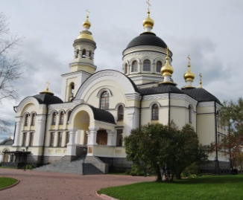 | 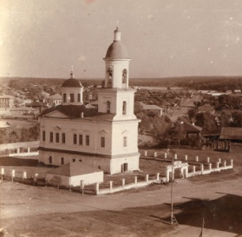 | 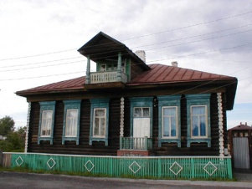 | 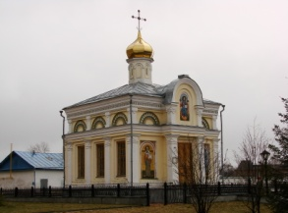 | 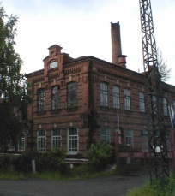
 | 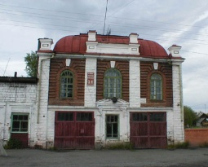 |  | 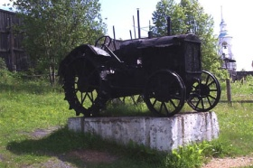 | 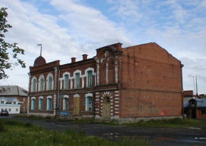 | 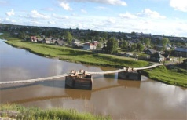
 | 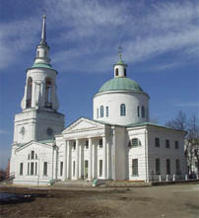 | 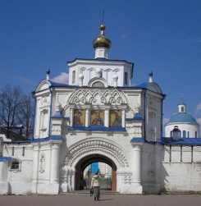 | 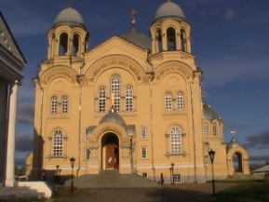 | 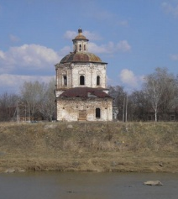 | 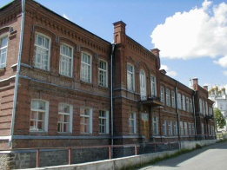
 | 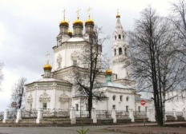 | 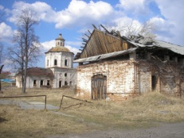 | 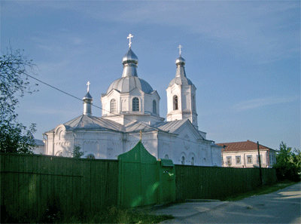
Match the date and the historical event.
- in spring 1598 | - the Cross Cathedral was finally closed
- in 1783 | - the Tsar approved the coat-of-arms
- in 1604 | - the Protection Nunnery was established
- in 1990 | - Nikolaev monastery was revived to spiritual life
- In 1621 | - the closing of St. Nickolas Monastery
- on Sept. 12, 1905 | - the Protection nunnery was reopened.
- in 30-ies | - Saint Nikolaev monastery was founded
- in 1990 | - St. Nikolavesky monastery was returned to the Orthodox  Church
- in 1926 | - the construction of Verkhoturye
- in 1960s | - Verkhoturye is still kept the rudiments of GULAG
- in 1991 | - Holy Cross Cathedral was founded

Sign the postcards. Write the name of the monument and the date of its foundation. What do you know about these monuments?

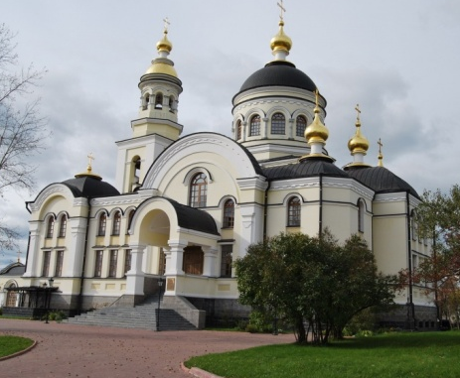
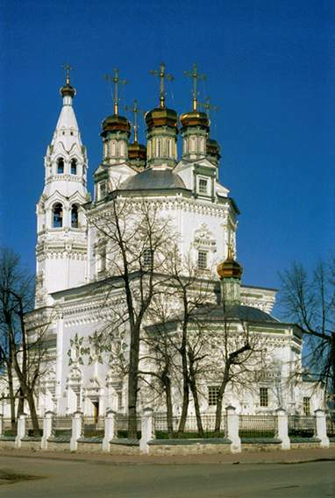

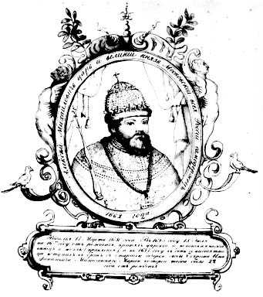
Who are these people? What do you know about them?

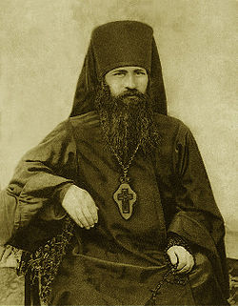
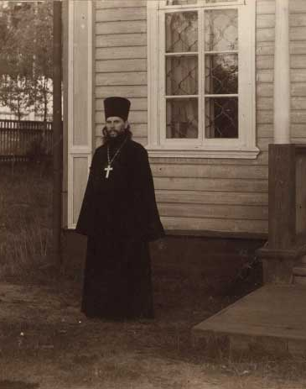

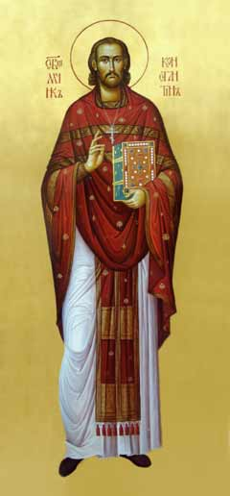
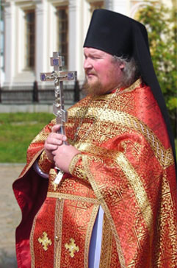
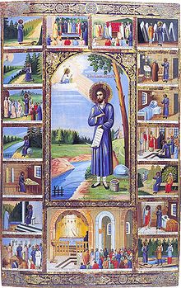

Make a map of Verkhoturye.
Sign the names of the monuments.

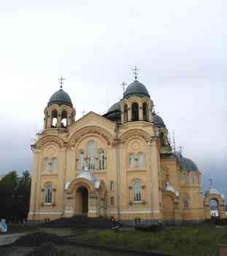
Read the texts and match them with the pictures.
The monastery was founded in 1604. Monk Ion was the founder of the monastery. In 1604 he asked permission at Tsar Boris Godunov for construction of a temple after the name of Saint Nikolay Wonder Maker with parts of it after the names of Saint Boris and Gleb.( Svyato-Nikolayevskeyeo monastery)

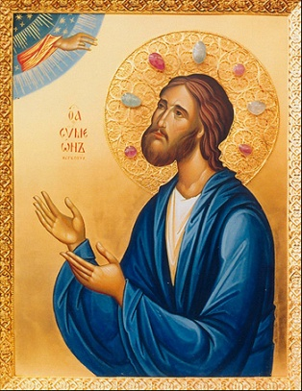
This cathedral was founded on September, 12th, 1905 - on the holiday of transferring the relics of Saint Simeon Wonder Maker. On September, 11th, 1913, during celebrating the 300 anniversary of Romanovs dynasty Cross-erection cathedral became one of the greatest temples in Russia. It was capable to place simultaneously near 4000 people.
( Krestovozdvizhenskiy cathedral)

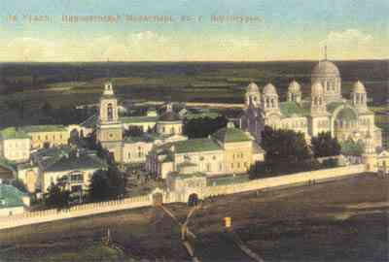
This cathedral was founded in 1703. Its place in the lay-out of the Kremlin forms monolithic ensemble with fortifications adjoining them. Its lay-out is unique as the cathedral is a combination of a temple octahedral drum. This cathedral is the bright sample of style of the baroque which has reached the greatest blossoming in cities of Siberia at the end of XVII - first half of XVIII centuries.( The Trinity Church)
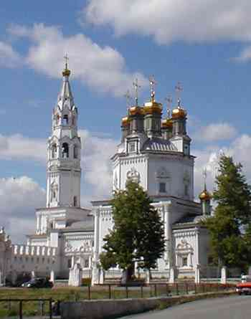
He worked wonders in Verkhoturye. According to the legend, a nobleman left his native land in European Russia and settled in the village. He made his living by fishing and sewing fur-coats. He didn't live more than 40 years but his body survived in the ground undeceived for many years. His relics were subjected to examination and in September 12, 1704 moved to St. Nickolas Monastery in Verkhoturye.(Simeon)
Translate these words from English into Russian and tell 2-3 sentences about any monument .
- The Trinity Church
- St. Michael Archangel Church
- Nicol church of the Svyato-Nikolayevskeyeo monastery
- Transfiguration Church
- Simeon –Ann’s above gates church of the Saint-Nikola’s monastery
- House for dignitaries
- Krestovozdvizhenskiy cathedral of the Svyato-Nikolayevskeyeo monastery
- The Protection Nunnery
- The church of John the Baptist
- The Cathedral of Exaltation of the Holy Cross
- The church of Risen.
- The Church of the Cover of Saint Virgin Mary
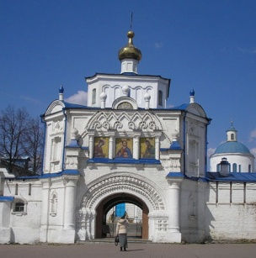
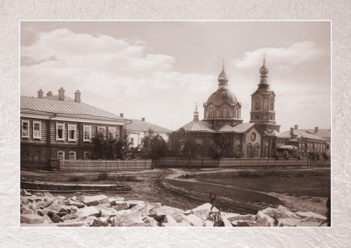
Match the modern and old pictures.

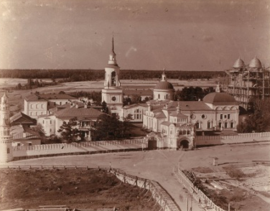

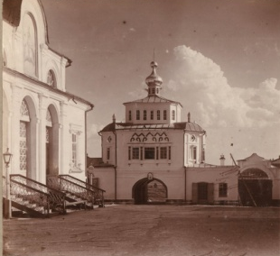
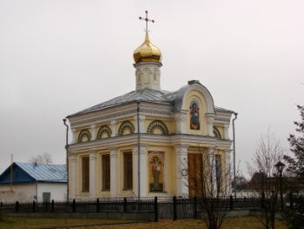
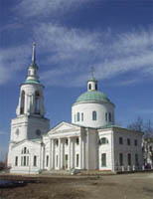
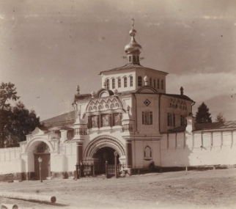
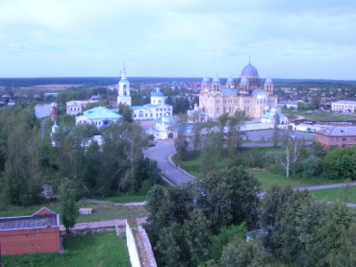
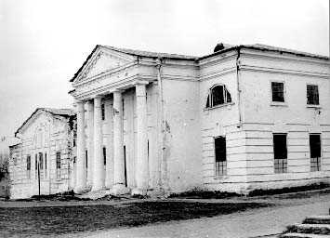

Источники:
Золотая книга Урала (книга не найдена, имеются копии страниц)
http://верхотурье.рф
http://верхотурье.рф/merkushino
http://www.nashural.ru/index.htm- Старинные фото начала XX века, выполненные известным фотографом С.М. Прокудиным-Горским.
http://ru.wikipedia.org/wiki/Заглавная_страница
http://www.siberianway.ru/engl/index.html
http://www.simeonprav.ru/history
http://www.isfarinka.ru
http://www.sedmitza.ru/index.html
http://v-xram.narod.ru/cumeon3.html

